**How to setup a MySQL database on Raspberry Pi**

**Reference guides:**

https://pimylifeup.com/raspberry-pi-mysql/

https://pimylifeup.com/raspberry-pi-phpmyadmin/

https://randomnerdtutorials.com/raspberry-pi-apache-mysql-php-lamp-server/

---------------------------------------------------------------------------------------------------------------------

As MySQL will be used on Raspberry Pi which uses Linux, we need to download a LAMP (Linux, Apache, MySQL and PHP) stack. MySQL is a relational database management system using which you can store large volumes of data.

**Step 1:**

Update existing package list and all installed packages using the following commands:

sudo apt update

sudo apt upgrade -y

**Step 2:**

Install Apache2 on Raspberry Pi. Apache2 is a web server software that handles requests to access a web page. Install using the following command:

sudo apt install apache2 -y

To test your installation, change to the /var/www/html directory and index.html should be in that folder:

cd /var/www/html  
ls -al

To open that page in your browser, you need to find out the Raspberry Pi IP address using:

ifconfig

If you open your RPi IP address in your local network, a similar web page should load:

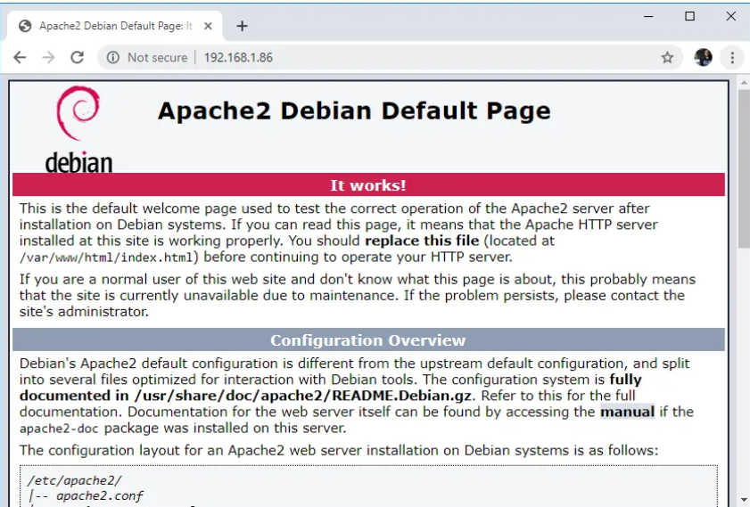

**Step 3:**

PHP is a server-side scripting language. Install PHP on Raspberry PI while still in the /var/www/html directory using:

sudo apt install php -y

You can remove index.html and create a PHP script to ensure correct installation:

sudo rm index.html

sudo nano index.php

In your index.php file add the following code to echo “hello world” message:

<?php echo “hello world”; ?>

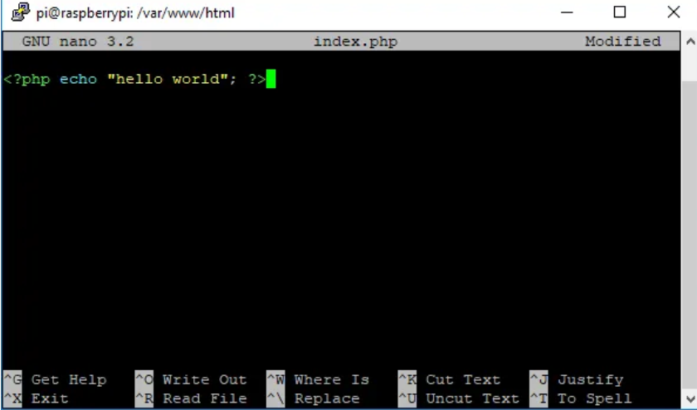

Save the file by pressing Ctrl+X, followed by y and press Enter to exit. Restart Apache2:

sudo service apache2 restart

To test if Apache2 is serving .php files, open the **Raspberry pi IP address** and it should display “hello world” message:

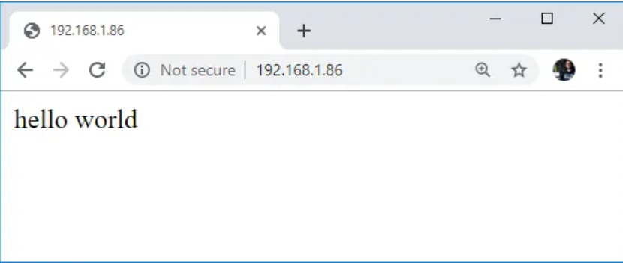

In case there is nothing displayed, or error is shown, these were some additional installations that I carried forth:

sudo apt install php libapache2-mod-php -y

sudo apt install php7.3 php7.3-mbstring php7.3-mysql php7.3-curl php7.3-gd php7.3-zip -y

sudo apt remove libapache2-mod-php

sudo apt install libapache2-mod-php7.3

sudo a2enmod php7.3

sudo a2dismod mpm_event

systemctl restart apache2

sudo a2dismod mpm_event

sudo a2enmod php7.3

systemctl restart apache2

sudo nano index.php

Add your php code: <?php echo “hello world”; ?> , save the file and view it in the browser.

**Step 4:**

Install MySQL server software and PHP-MySQL packages on the Raspberry Pi using the following command:  
sudo apt install mariadb-server php-mysql -y  
sudo service apache2 restart

**Step 5:**

Once the MySQL server is installed on the Raspberry pi, secure it by setting a password for the “root” user. By default, MYSQL is installed without any password set up, hence, it can be accessed without any authentication. Use the following command to secure the server:

sudo mysql_secure_installation

Follow the prompts to set a password for the root user and secure your MySQL installation. Answer “Y” to all prompts when asked to answer “Y” or “N”. Make sure to note down the password set during the process.

**Step 6 (Install phpMyAdmin):**

You will need to have the password you set up for the root MYSQL account. If you do not have this, you will not be able to install PHPMyAdmin.

Next, install phpMyAdmin on RPi. The software phpMyAdmin is written in PHP which handles MySQL using a web interface. Install phpMyAdmin using the following:

sudo apt install phpmyadmin -y

PHPMyAdmin installation program will ask you few questions. Use the dbconfig-common.

* Select **Apache2** when prompted and press the Enter key
* Configuring **phpmyadmin**? **OK**
* Configure database for phpmyadmin with **dbconfig-common**? **Yes**
* Type your **password** and press **OK**

Next, enable the PHP MySQLi extension:

sudo phpenmod mysqli

sudo service apache2 restart

**Step 7 (Configuring Apache for phpMyAdmin):**

Edit the “**Apache2.conf**” file by entering the following command into the terminal:

sudo nano /etc/apache2/apache2.conf

Now add the following line to the bottom of the file:

Include /etc/phpmyadmin/apache.conf

Once done, save and exit by pressing **CTRL+X** and then pressing **Y** and then **ENTER**.

Restart the Apache service by running the following command:

sudo service apache2 restart

**Step 8:**

When you go to your RPi IP address followed by /phpmyadmin (IP address/phpmyadmin), there will most probably be a “Not Found” error page in the browser:

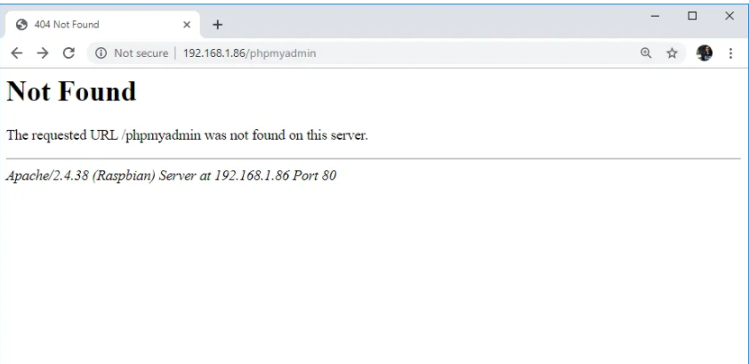

If you see this, move the phpmyadmin folder to this directory: /var/www/html using the following command:

sudo ln -s /usr/share/phpmyadmin /var/www/html/phpmyadmin

While still in /var/www/html directory, list the files and phpmyadmin folder should be shown:

ls

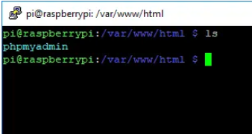

**Step 9:**

Reload the webpage (RPi IP address/phpmyadmin) and a login page for phpMyAdmin web interface should be displayed:

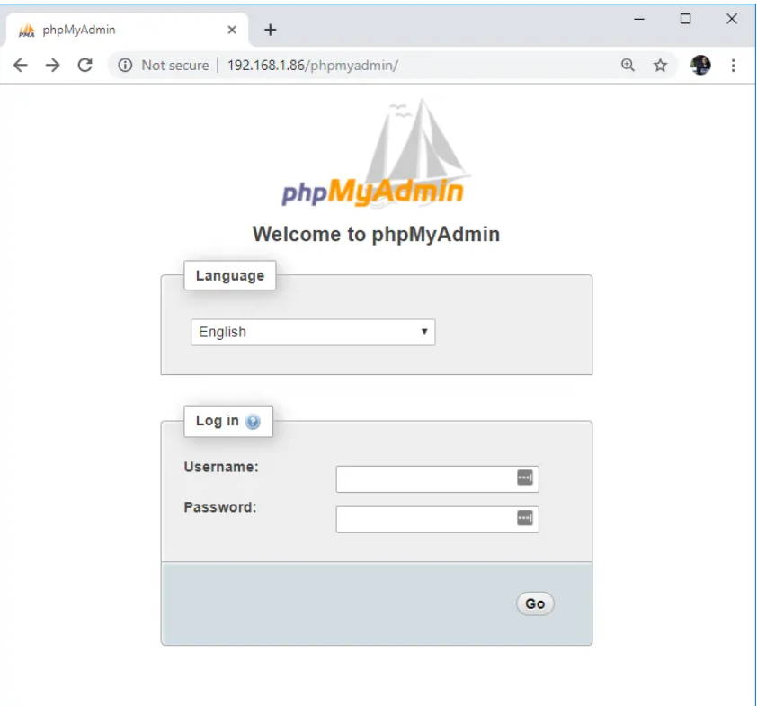

Enter the username (should be **Username = root**) and the password set during the installation.

Press **Go** button and the following page will be loaded:

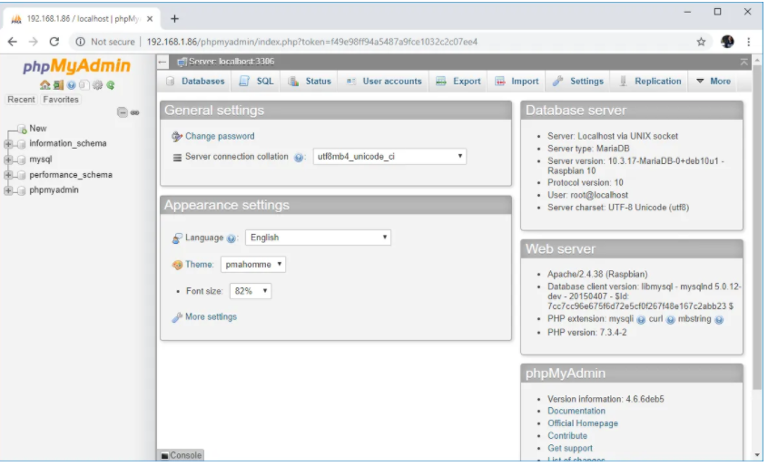

That is, it! You should have the privileges to create a new database. You will be able to now create new databases and tables within those databases and save and process the data. I always used the default user (root) but new users can also be added that can create new databases.

**Additional installations:**

sudo install mysql-server

sudo apt-get install mariadb-server

sudo apt-get install mariadb-client

pip install mysql-connector-python

sudo apt install libapache2-mod-php